**GRAPH**

Graph is a two dimensional drawing that represents the relationship by means of a line, curve, a series of bars or other symbols.

**GRAPH FOR DIABETES**

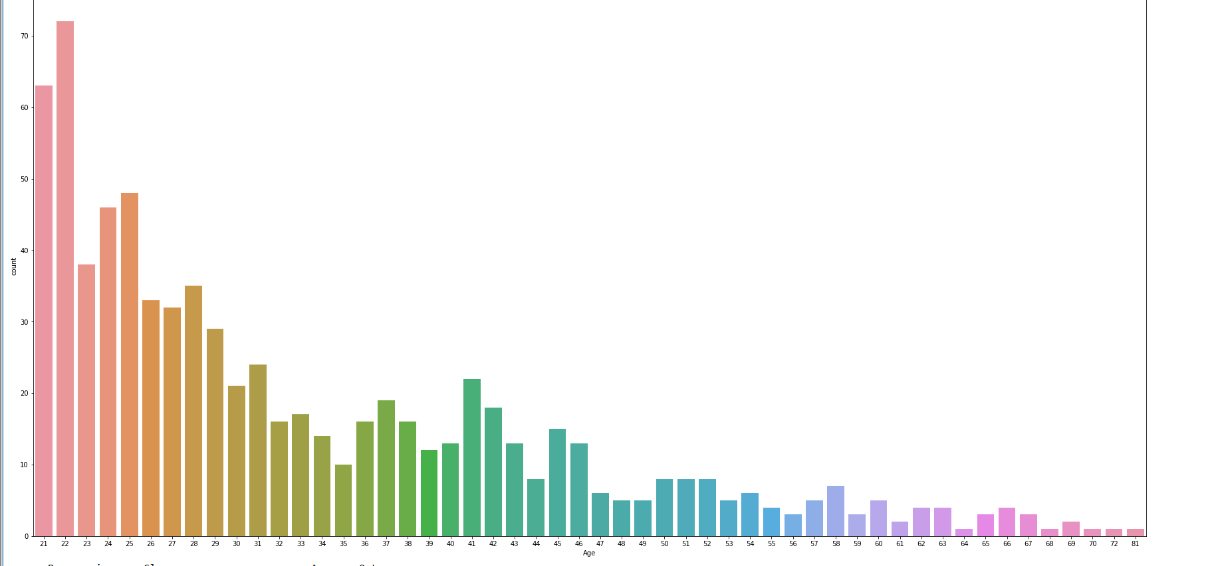

**GRAPH FOR WINE QUALITY**

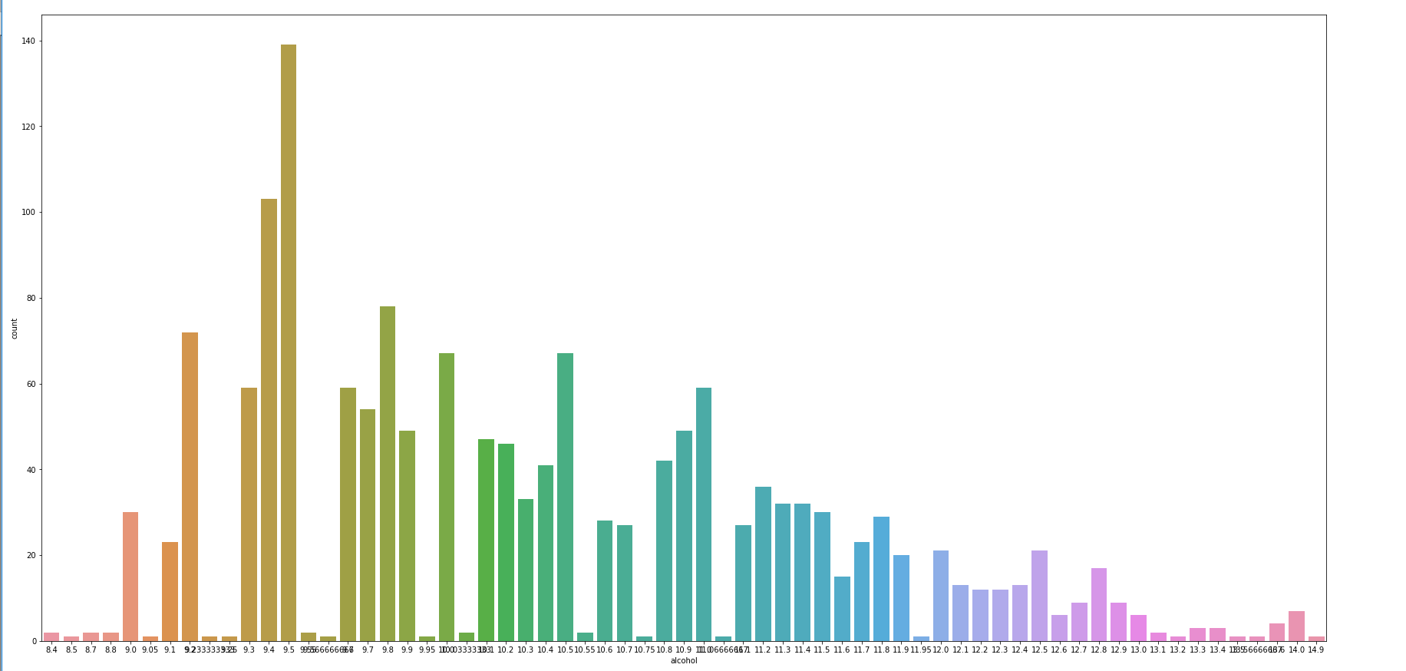

**BOX PLOT**

Box plot is the simplest form of representing statistical data on a plot which is rectangular in shape. It is drawn to represent the values in second and third quartiles.

**BOX PLOT FOR DIABETES**

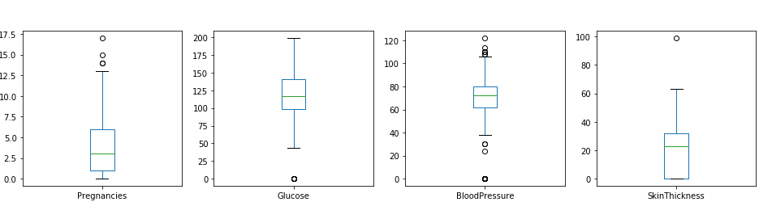

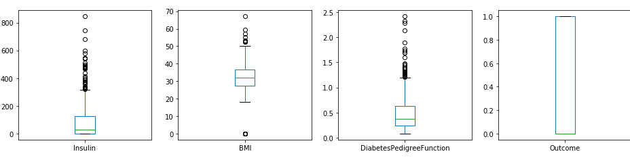

**BOX PLOT FOR WINE QUALITY**

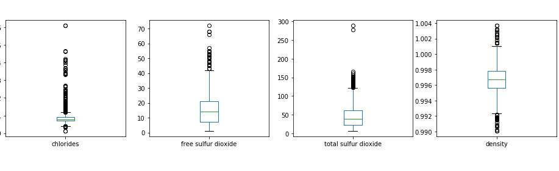

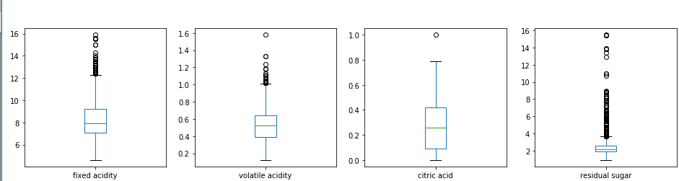

**ACCURACY OF PREDICTION**

A best learner is one which has excellent prediction accuracy; in other words which has a lower prediction error. Prediction accuracy is expressed as the correlation between the actual prediction and the AMS prediction. Accuracy of 0 indicates random guess, whereas the accuracy of 1 indicates the actual score.

**ACCURACY OF DIABETES PREDICTION**

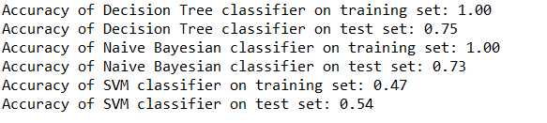

**ACCURACY OF WINE QUALITY PREDICTION**

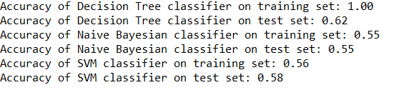

**FINAL OUTPUT OF IMAGE CLASSIFICATION**

**CAT IMAGE**

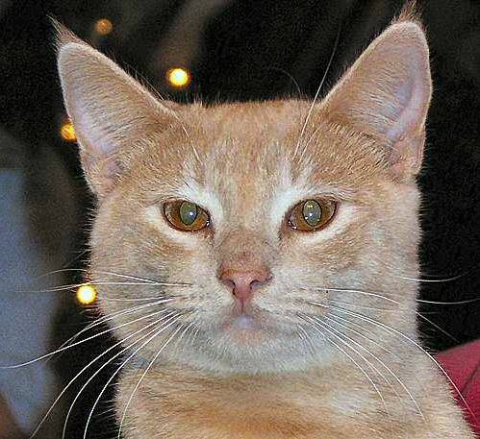

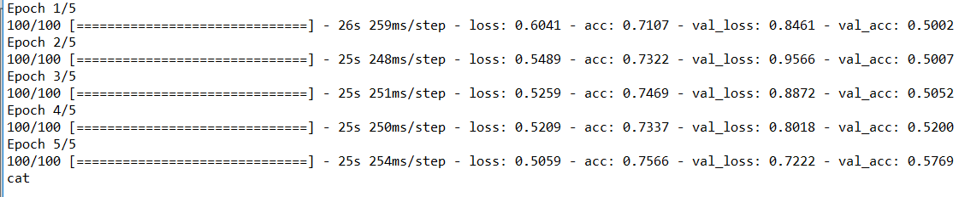

**DOG IMAGE**

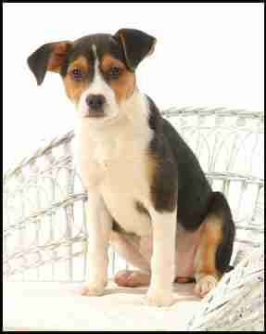

**FIG 4.9**

